Assignment 9.2
Robert Breutzmann's CSD420 GitHub
Creating the Database and Populating Data in Terminal
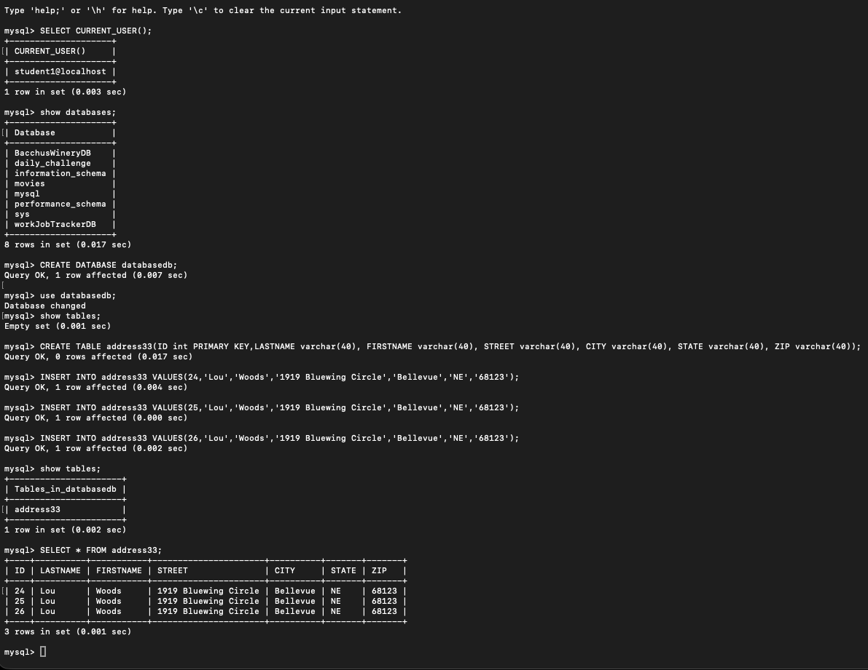
Short Java program output to demonstrate connection to the database
